Week 3 Tutorial – Problem Solving Challenge
Step 1: Understand and Define the Problem (Analyse)
The problem here requires designing a combinational logic circuit that triggers an alarm in a car whenever the seat in a car is occupied and are not fastened. The circuit must have two active-HIGH signals DRIV and PASS to identify the occupant representing the driver and passenger respectively. If the car IGN is ON and none of the seats are unfastened, the alarm must be activated (LOW).
Step 2: Organise and Describe the Data
Symbol | Meaning | Type | Active Logic
DRIVE | Driver in the seat | Input | HIGH or 1
PASS | Passenger in the seat | Input | HIGH or 1
$$\overline{BELTD}$$ | Driver’s seatbelt unfastened | Input | LOW or 1
$$\overline{BELTP}$$ | Passenger’s seatbelt unfastened | Input | LOW or 0
IGN | Ignition switch is ON | Input | HIGH or 1
ALARM | Alarm sound triggered | Output | LOW or 0

Step 3: Plan the Solution (Design the Algorithm)
  - Algorithm (in plain English)
- Check if the IGN is HIGH or LOW. The ignition switch must be HIGH.
- If driver is in the seat and seatbelt is fastened, then the DRIV = 1 and BELTD = 0.
- If passenger is in the seat and the seatbelt is not fastened, then the PASS = 1 and BELTP = 0.
- If either condition above is TRUE and IGN = 1, the alarm gets triggered, LOW.
- Otherwise, the alarm remains HIGH.

  - Truth Table
INPUT |  |  |  |  | OUTPUT
IGN | DRIV | BELTD | PASS | BELTP | ALARM
1 | 0 | 0 | 0 | 0 | 1
1 | 0 | 0 | 0 | 1 | 1
1 | 0 | 0 | 1 | 0 | 1
1 | 0 | 0 | 1 | 1 | 1
1 | 0 | 1 | 0 | 0 | 1
1 | 0 | 1 | 0 | 1 | 1
1 | 0 | 1 | 1 | 0 | 1
1 | 0 | 1 | 1 | 1 | 1
1 | 1 | 0 | 0 | 0 | 0
1 | 1 | 0 | 0 | 1 | 0
1 | 1 | 0 | 1 | 0 | 0
1 | 1 | 0 | 1 | 1 | 0
1 | 1 | 1 | 0 | 0 | 1
1 | 1 | 1 | 0 | 1 | 1
1 | 1 | 1 | 1 | 0 | 0
1 | 1 | 1 | 1 | 1 | 1
ALARM triggered = 0, ALARM not triggered = 1.
  - Boolean Expressions (SOP)
- DRIV.$\overline{BELTD}$.$\overline{PASS}$.$\overline{BELTP}$.IGN
- DRIV. $\overline{BELTD}$.$\overline{PASS}$.BELTP.IGN
- DRIV. $\overline{BELTD}$.PASS.$\overline{BELTP}$.IGN
- DRIV. $\overline{BELTD}$.PASS.BELTP.IGN
- DRIV,BELTD,PASS.$\overline{BELTP}$.IGN
ALARM = DRIV.$\overline{BELTD}$.$\overline{PASS}$.$\overline{BELTP}$.IGN + DRIV. $\overline{BELTD}$.$\overline{PASS}$.BELTP.IGN + DRIV. $\overline{BELTD}$.PASS.$\overline{BELTP}$.IGN + DRIV. $\overline{BELTD}$.PASS.BELTP.IGN + DRIV.BELTD.PASS.$\overline{BELTP}$.IGN

- Flowchart
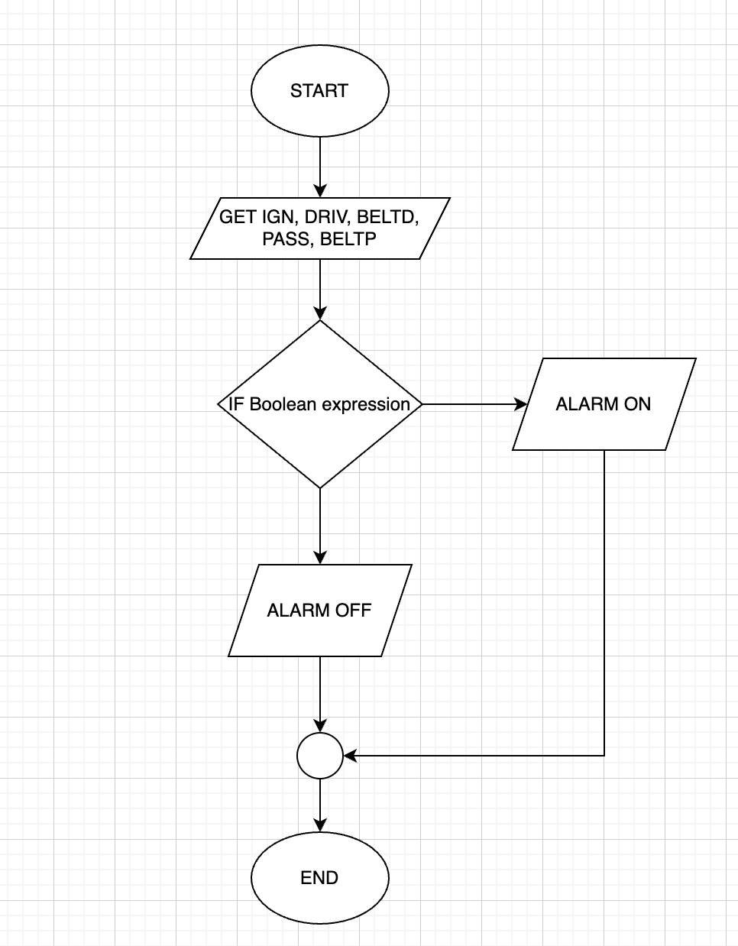
Pseudocode
START
GET IGN, DRIV, BELTD, PASS, BELTP
IF DRIV.$\overline{BELTD}$.$\overline{PASS}$.$\overline{BELTP}$.IGN + DRIV. $\overline{BELTD}$.$\overline{PASS}$.BELTP.IGN + DRIV. $\overline{BELTD}$.PASS.$\overline{BELTP}$.IGN + DRIV. $\overline{BELTD}$.PASS.BELTP.IGN + DRIV.BELTD.PASS.$\overline{BELTP}$.IGN
THEN ALARM ON
ELSE ALARM OFF
END
Step 4: Test and Refine the Solution (Debug and Verify)
- All the seats are unoccupied.
IGN | DRIV | BELTD | PASS | BELTP | EXPECTED ALARM
1 | 0 | 0 | 0 | 0 | 1
Here, no driver or the passenger is present in the car, hence, the alarm won’t be triggered when the ignition is ON.

- The driver is present in the seat and the seatbelt is unfastened.
IGN | DRIV | BELTD | PASS | BELTP | EXPECTED ALARM
1 | 1 | 0 | 0 | 0 | 0
Here the driver is present in the car, and the seatbelt is unfastened, hence, the alarm gets triggered when the ignition is ON.

- The passenger is present in the seat and the seatbelt is fastened.
IGN | DRIV | BELTD | PASS | BELTP | EXPECTED ALARM
1 | 0 | 0 | 1 | 1 | 1
Here, the passenger is only present in the car, and the seatbelt is fastened, so, the alarm won’t be triggered when the ignition is ON.

Submitted By Vanisha Rai
Student No.: 3319008
Tutor: Sangay Wangmo

